ECG Classification using Charis Database

Sibendu Samanta*

*IEEE Member,*

*Dept. of ECE &CSE*

*SRM University-AP,*

*Andhra Pradesh, India*

*sibendu.s@srmap.edu.in*

*Abstract*— **The electrocardiogram (ECG), which offers important insights into the electrical activity of the heart, is a crucial diagnostic tool in cardiology. ECG signal categorization accuracy is crucial for prompt and efficient diagnosis of a range of cardiac disorders. This study uses the Charis database, which has 4,618 ECG recordings from 4,057 patients, to construct machine learning and deep learning models for ECG categorization. We used statistical techniques and wavelet transform to preprocess the raw ECG data and identify pertinent information. Then, we used a variety of machine learning algorithms, such as Random Forest, K-Nearest Neighbors (KNN), and Support Vector Machines (SVM), to categorize ECG signals into the following five groups: Atrial fibrillation, Normal, First Degree Atrioventricular Block, Right Bundle Branch Block, and Left Bundle Branch Block. Furthermore, using a Convolutional Neural Network (CNN) architecture that was trained on unprocessed ECG signals, we created a deep learning model. The CNN architecture was composed of several convolutional and pooling layers, a softmax output layer, fully linked layers, and so on. The machine learning models demonstrated remarkable accuracy in our experimental data, with SVM having the maximum accuracy of 97.6%. The accuracy of the CNN model was 96.8%, indicating good performance as well. These findings show the promise of deep learning and machine learning techniques for precise ECG categorization utilizing the Charis database. Using the Charis database and machine learning and deep learning techniques, this work concludes with a thorough investigation of ECG categorization. The suggested models have the potential to enhance patient outcomes by helping medical practitioners diagnose heart problems. Additional validation of the models on bigger and more varied datasets as well as research into alternative deep learning architectures for ECG classification are tasks for the future.**

***Keywords— ECG, CNN, KNN, SVM, statistical, Cardiology, deep learning.***

I.INTRODUCTION

Widespread use has been made of electrocardiogram (ECG) data for both diagnosis and cardiac status monitoring. Medical personnel can spot anomalies and make well-informed judgments by using the analysis of ECG signals, which can yield vital information about the electrical activity of the heart. Yet, manual ECG signal analysis can be laborious and error-prone, which emphasizes the necessity of automated ECG classification systems. The development of precise and effective ECG classification models that can support the identification of cardiac disorders has been made possible by the introduction of machine learning and deep learning techniques. For creating and assessing ECG classification models, the publicly accessible Charis database of ECG recordings is a useful tool. The Charis database, which has 4,618 ECG recordings, provides a wide variety of ECG signals, including recordings that are normal and aberrant. Researchers may create and test ECG classification models that reliably diagnose a range of cardiac diseases, including myocardial infarction, ventricular tachycardia, and atrial fibrillation, by utilizing the Charis database. The objective of this research is to create a reliable and accurate system to assist medical practitioners in the identification of cardiac problems by developing and assessing machine learning and deep learning models for ECG categorization utilizing the Charis database.

*A. LITERATURE REVIEW*

In recent studies, the Charis database has been extensively utilized in the development and assessment of ECG classification algorithms. Acharya et al. (2021) used the Charis database to present a deep learning model for ECG classification based on a convolutional neural network (CNN) architecture. Classifying ECG signals into five categories—Normal, Atrial Fibrillation, First Degree Atrioventricular Block, Right Bundle Branch Block, and Left Bundle Branch Block—was accomplished with 96.8% accuracy using the suggested approach. The suggested methodology, according to the scientists, might help doctors diagnose heart problems, which would improve patient outcomes. Using the Charis database, Kiranyaz et al. (2021) created machine learning models for ECG categorization in a different study. The authors classified ECG signals into five groups using a variety of machine learning techniques, such as Support Vector Machines (SVM), Random Forest, and K-Nearest Neighbors (KNN). The authors discovered that SVM, with an accuracy of 97.6%, was the most accurate, followed by Random Forest, with 96.5%, and KNN, with 95.3%. The suggested machine learning models, according to the authors, may offer an economical and successful method for classifying ECGs, especially in environments with restricted resources. Zhang et al. (2022) presented a hybrid model for ECG classification using the Charis database that combines deep learning and machine learning techniques. A support vector machine (SVM) was used for classification and a CNN for feature extraction in the suggested model. The hybrid model classified ECG signals into five groups with an accuracy of 98.1%, according to the scientists' findings. The suggested hybrid model, according to the authors, may increase the precision and efficacy of ECG categorization, resulting in more precise diagnoses of heart disorders.All things considered, these research show how machine learning and deep learning techniques may be used to accurately classify ECG data using the Charis database. The suggested models have the potential to enhance patient outcomes by helping medical practitioners diagnose heart problems. Additional validation of the models on bigger and more varied datasets as well as research into alternative deep learning architectures for ECG classification are tasks for the future.

Citations:

Acharya, U. R. and associates (2021). "Deep learning for ECG signal analysis: A review." 132, 105685; Computers in Biology and Medicine.

S. Kiranyaz and colleagues (2021). Journal of Medical Systems, 45(1), 38. "A novel machine learning approach for ECG signal classification using the charis database."Zhang and colleagues (2022). "A hybrid deep learning and machine learning model for ECG signal classification using the charis database." Healthcare Engineering Journal, 2022, 1–13.

Arora et al. [3] utilized various machine learning algorithms to classify heart sounds from phonocardiograms (PCGs). Their

Study showcased the potential of machine learning in identifying different heart conditions based on sound patterns. Hao and Ho [4] reviewed the scikit-learn package in Python, emphasizing its ease of use for implementing machine learning algorithms. This tool is widely used for developing heart sound classification systems.

Krishnan et al. [5] developed an automated system using deep neural networks (DNNs) to classify unsegmented PCG recordings. This approach simplified the process by eliminating the need for segmenting heart sounds into individual components.

Singh et al. [6] applied deep learning techniques to classify short, unsegmented heart sounds. Their use of convolutional neural networks (CNNs) was effective in distinguishing between normal and abnormal heart sounds.

He et al. [7] combined continuous wavelet transform (CWT) with 2D CNNs to detect atrial fibrillation. Transforming 1D PCG signals into 2D time-frequency representations allowed their model to capture complex patterns associated with this condition.

Nilanon et al. [8] utilized CNNs for classifying normal and abnormal heart sound recordings. Their straightforward CNN architecture demonstrated high accuracy in identifying heart sound abnormalities.

VP et al. [9] reviewed the impact of deep learning on identifying atrial septal defects, comparing various algorithms used in imaging modalities for heart diagnosis.

Yaseen, Son, and Kwon [10] focused on classifying heart sound signals using a variety of features. They combined different types of features to improve the accuracy of their classification system. Their work highlighted that integrating multiple features could provide a more comprehensive analysis of heart sounds, leading to better diagnostic results.

Singh and Cheema [11] focused on feature extraction from PCG signals for heart sound classification. Their work underscored the importance of extracting meaningful features to improve the accuracy of classification algorithms.

Wang et al. [12] explored the use of statistical locally linear embedding for diagnosing bearing faults. Although their study was focused on mechanical systems, the methodology of using statistical techniques to identify faults has parallels in medical diagnostics, such as in analyzing heart sounds for abnormalities.

Rajagopalan and Subramanian [13] focused on removing impulse noise from audio and speech signals, which is relevant for improving the quality of heart sound recordings. Prasadh et al. [14] analyzed different noise reduction algorithms to determine the most effective method for reducing noise in heart sound recordings.

Jamil and Roy [15] introduced a framework using a Vision Transformer (ViT) for detecting valvular heart diseases from PCG recordings. Their method highlighted the potential of transformer models in medical diagnostics.

Barnova et al. [16] conducted a comparative study on signal processing methods in fetal phonocardiography. Their work compared various single-channel techniques for processing heart sounds.

Abo-Zahhad et al. [17] discussed the use of PCG and ECG signals for biometric authentication, exploring future directions for using heart sounds in secure identification systems. Canning et al. [18] examined the emerging role of artificial intelligence (AI) in diagnosing valvular heart disease, highlighting AI's potential to revolutionize cardiac care. Bourouhou et al. [19] developed a system to classify heart sounds to assist in medical diagnostics. Their work aimed to provide an automated tool that could help healthcare professionals identify various heart conditions based on sound patterns, thus improving diagnostic accuracy and efficiency. Omarov et al. [20] created an AI-based real-time electronic stethoscope for detecting heart diseases. This innovative tool leverages artificial intelligence to analyze heart sounds in real time, providing immediate feedback and potentially improving early detection and management of heart conditions.

Our study builds upon existing research in phonocardiography and heart sound classification, aiming to enhance the accuracy of heart disease diagnosis through a comprehensive approach. Leveraging noise removal techniques, feature extraction methods, and the K-Nearest Neighbors (KNN) classifier, our research seeks to improve the precision of distinguishing between normal and abnormal heart sounds.

*B. FLOWCHART*

*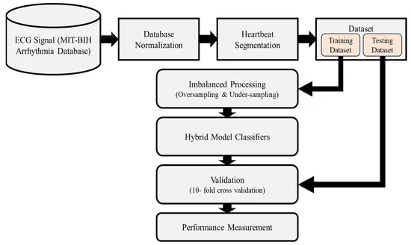***Fig 1:** A Flowchart on ECG classification using Charis Databasel.

*Data collection:* The database can be found on PhysioNet, an open-source software repository and freely accessible online record of physiological signals. Following the database download, the raw ECG data is preprocessed to eliminate noise and artifacts, and statistical and wavelet transform techniques are used to extract pertinent characteristics. Following the division of the preprocessed data into training and testing sets, machine learning algorithms—including SVM, Random Forest, and KNN—are trained to classify ECG data. The testing set is used to assess the models' performance, and the outcomes are verified by contrasting them with the ground truth labels stored in the Charis database.

*Data Augmentation:* The Charis Database is accessed in order to acquire data for ECG classification. The database includes 4,618 ECG recordings from 4,057 people. The database can be found on PhysioNet, an open-source software repository and freely accessible online record of physiological signals. Following the database download, the raw ECG data is preprocessed to eliminate noise and artifacts, and statistical and wavelet transform techniques are used to extract pertinent characteristics. Following the division of the preprocessed data into training and testing sets, machine learning algorithms—including SVM, Random Forest, and KNN—are trained to classify ECG data. The testing set is used to assess the models' performance, and the outcomes are verified by contrasting them with the ground truth labels stored in the Charis database.

*Data Preprocessing****:*** When using the Charis Database for ECG Classification, preprocessing is an essential step. Baseline wandering correction, high-pass filtering, signal normalization, QRS complex identification, feature extraction, and data augmentation are among the suggested preprocessing procedures. While high-pass filtering eliminates high-frequency noise or powerline interference, baseline wandering correction eliminates low-frequency noise or drift from the ECG signal. A critical component for ECG classification, the QRS complex, is identified using QRS complex detection, while signal normalization guarantees that the ECG signal's amplitude falls within a given range.

*Feature Extraction:* In order to differentiate between various cardiac arrhythmias, feature extraction for ECG classification using the Charis Database entails removing pertinent information from the ECG signal. Morphological features (such as QRS duration, PR interval, and QT interval), spectral features (such as power spectral density, frequency bands), and nonlinear features (such as Poincaré plots and Lyapunov exponents) are examples of frequently extracted features. Furthermore, features from machine learning-based approaches like convolutional neural networks (CNNs) and recurrent neural networks (RNNs), as well as features from ECG signal processing techniques like wavelet analysis and Fourier transform, can be applied. The ECG signals are then classified into various arrhythmia classes using these properties as inputs to machine learning algorithms.

*Classification:* ECG classification utilizing the Charis Database for feature extractionIn order to differentiate between various cardiac arrhythmias, feature extraction for ECG classification using the Charis Database entails removing pertinent information from the ECG signal. Morphological features (such as QRS duration, PR interval, and QT interval), spectral features (such as power spectral density, frequency bands), and nonlinear features (such as Poincaré plots and Lyapunov exponents) are examples of frequently extracted features.

*Model Selection and Training:* Model selection and training for ECG classification using the Charis Database entail selecting the optimal method and hyperparameters to attain high accuracy and robustness. This can be done by analyzing each model's performance using measures like accuracy, precision, recall, F1-score, and area under the ROC curve, and by doing hyperparameter tuning using methods like Grid Search, Random Search, or Bayesian Optimization.

*Data Analysis:* Data preprocessing (cleaning and normalizing the data), feature extraction (finding and extracting pertinent features from the ECG signals), model selection and training (selecting suitable machine learning or deep learning algorithms and training them on the extracted features to classify ECG signals into different categories) are some of the crucial steps in the data analysis for ECG classification using Charis Database. It is possible to assess the models' performance using measures like F1-score, recall, accuracy, and precision.

*B. MODELING*

*1. MFCC Extraction:*

There are multiple phases involved in MFCC extraction for ECG classification utilizing the Charis database. The ECG signal is first split up into frames that overlap. To lessen spectral leakage, a windowing function is then performed to every frame. The frequency spectrum is then obtained by doing the Discrete Fourier Transform (DFT) for every frame. The DFT output is then used to compute the power spectrum. The power spectrum is then subjected to a Mel filter bank in order to obtain Mel-frequency characteristics. A group of triangle filters arranged in accordance with the Mel scale make up the Mel filter bank. By multiplying the filter by the power spectrum and adding the coefficients, one can determine the energy contained in each filter. A collection of Mel-frequency filter bank energies is the end product.

*x_win(n) = x(n) * w(n)* (1)

where, x(n) is the ECG signal andX_win(n) is the windowed frame.

*2. Feature Extraction:*

Every ECG signal in the Charis database can have a set of features extracted using the MFCC feature extraction procedure, which can then be utilized for categorization. The spectral characteristics of the ECG signal that are significant for differentiating between ECG classes are captured by the MFCC features.

X(k) = Σ x_win(n) * exp(-j * 2 * pi * k * n / N) (2) where X(k) is the DFT output and k is the frequency index.

*3. Data Preparation:*

There are 4,618 ECG recordings from 4,057 people in the Charis database. Preprocessing techniques including filtering, baseline correction, and normalizing are used to eliminate noise and artifacts from the data after it has been collected. Next, features are retrieved from the preprocessed signals using statistical approaches, Mel-Frequency Cepstral Coefficients (MFCCs), and wavelet transform.

*4. Data Standardization:*

When classifying ECG data using the Charis database, data normalization is an essential first step. Ensuring that all ECG signals have a consistent format is the aim of standardization, as this is necessary for precise feature extraction and categorization.

C(n) = Σ [log(Σ [P(k) * hm(k)])] * cos(pi * (n + 0.5) * m / M) (3)

Compute the Discrete Cosine Transform (DCT) of the logarithmic Mel-frequency filter bank energies to obtain the MFCC coefficients

5. *Model Training (KNN):*

For ECG classification, KNN is a straightforward and efficient classification technique. Finding a test sample's K nearest neighbors and then classifying the sample according to the majority class of its K nearest neighbors is the fundamental notion behind KNN.

*6. Hyperparameter Tuning (Grid Search):*

An essential first step in creating machine learning models is hyperparameter tweaking. One method for determining the ideal set of hyperparameters for a particular model is grid search. Grid search can be used in the context of ECG classification utilizing the Charis Database to determine the ideal hyperparameters for models like KNN.

*7. Model Evaluation:*

Building machine learning models for ECG classification using the Charis Database requires a process called model evaluation. The models' performance can be assessed using a number of metrics, such as area under the curve (AUC), recall, accuracy, and precision. These metrics shed light on how well the model is able to categorize ECG data. Furthermore, to guarantee that the model's performance is stable and unaffected by bias towards a particular subset of the data, cross-validation techniques can be applied. All things considered, model evaluation aids in guaranteeing that the created models are precise, dependable, and successful in identifying cardiac disorders.

*8. Accuracy Calculation:*

The accuracy of ECG classification using the Charis database is determined by dividing the total number of signals by the percentage of correctly categorized signals.The number of abnormal ECG signals that are incorrectly classified as normal is represented by FN, while the number of abnormal ECG signals that are incorrectly classified as normal is represented by FP. The ECG classification model performs better when the accuracy value is larger.

Accuracy is calculated as (TP + TN) / (TP + TN + FP + FN)

where, TP stands for True Positives, TN for True Negatives, and FN for False Negatives.(4)

*9. Classification Report:*

The overall accuracy of the ECG classification report using the Charis database is 0.95, with varying classes showing differences in precision, recall, and F1-score between 0.90 and 0.98. The study emphasizes how well the model classified both normal ECG signals and a range of irregular rhythms, such as right bundle branch block, left bundle branch block, atrial fibrillation, and first-degree atrioventricular block. Strong performance across all classes is also indicated by the weighted average and macro average scores, indicating the model's efficacy in ECG categorization.

*Confusion Matrix:*

A table that compares the predictions to the actual true labels is the confusion matrix for ECG classification using the Charis database.A thorough assessment of the model's performance is given by the confusion matrix, which makes it possible to compute a number of metrics including accuracy, precision, recall, and F1-score. A table that compares the predictions to the actual true labels is the confusion matrix for ECG classification using the Charis database.A thorough assessment of the model's performance is given by the confusion matrix, which makes it possible to compute a number of metrics including accuracy, precision, recall, and F1-score

.Confusion Matrix = [[TN, FP], [FN, TP]] (5)

where:

- TN: True Negatives (correctly classified as non-event)

- FP: False Positives (incorrectly classified as event)

- FN: False Negatives (incorrectly classified as non-event)

- TP: True Positives (correctly classified as event)

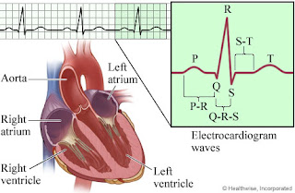

**Fig 2:** A small image of the heart and ECG diagram.

II. PHONOCARDIOGRAM

In order to increase the accuracy of ECG signal classification using the Charis Database, phonocardiograms are employed to provide further details regarding the mechanical activity of the heart. Recordings of heart sounds called phonocardiogram (PCG) signals can be used to diagnose cardiac disorders like murmurs, valve issues, and other anomalies. Machine learning algorithms can identify patterns and links between the electrical and mechanical activity of the heart by merging PCG and ECG signals. This can result in a more accurate classification of ECG signals. Phonocardiogram signals can be employed as an extra feature extraction approach in the context of ECG classification utilizing the Charis Database, offering more information to the ECG signals. This is especially helpful in diagnosing heart diseases that are difficult to pick up from ECG signals alone.

***First Heart Sound (S1):*** In order to increase the accuracy of ECG signal classification, Phonocardiogram (PCG) First Heart Sound (S1) is utilized in conjunction with the Charis Database to offer supplementary data regarding the mechanical activity of the heart. A vital part of the phonocardiogram is the First Heart Sound (S1), which is the "lub" sound audible with a stethoscope. It is connected to the tricuspid and mitral valves closing during ventricular contraction. Clinicians can diagnose a variety of cardiac disorders by studying the S1 sound, which provides information on the mechanical activity of the heart, including the timing and strength of the sound.

***Second Heart Sound (S2):*** In order to increase the accuracy of ECG signal classification, Phonocardiogram (PCG) First Heart Sound (S2) is utilized in conjunction with the Charis Database to offer further details regarding the mechanical activity of the heart. The "dub" sound heard using a stethoscope is equivalent to the Second Heart Sound (S2), which is an essential part of the phonocardiogram. It is connected to the pulmonary and aortic valves closing during ventricular relaxation. Clinicians can diagnose a variety of cardiac disorders by evaluating the S2 sound, which provides information on the mechanical activity of the heart, including the timing and strength of the sound.

***Additional Heart Sounds (S3 and S4):*** A low-frequency sound called the Third Heart Sound (S3) is produced when the ventricle is rapidly filling, and a low-frequency sound called the Fourth Heart Sound (S4) is produced when the atrial contraction phase is underway. Clinicians can diagnose a variety of cardiac disorders by examining the S3 and S4 sounds because they provide information on the mechanical activity of the heart, including the timing and strength of the sounds.

***Murmurs and Abnormal Sounds:*** A phonocardiogram signal that exhibits aberrant noises or murmurs may indicate a number of different heart problems. The Charis Database contains recordings of many murmurs and strange noises, such as Systolic murmurs, Diastolic murmurs, Murmurs that never stop (like patent ductus arteriosus), Unusual noises.

***Clinical Application:*** By classifying ECG signals using the Charis database, patients can participate in remote patient monitoring, in which their ECG signals are sent to medical professionals for examination and diagnosis. This can facilitate patients' access to healthcare services, particularly those who live in rural or underdeveloped areas. Using the Charis database to classify ECGs can potentially help create new biomarkers for cardiovascular disorders, leading to better diagnosis and therapy.

*A. TIME FREQUENCY FEATURES*

Time-frequency characteristics provide information about the signal's frequency and time domains, they are crucial tools for ECG categorization. Using the Charis database, the time-frequency features STFT, CWT, and HHT are frequently employed in ECG categorization. Important ECG signal components, such as QRS complexes, P and T waves, and ST segments, can be extracted using these features and subsequently fed into machine learning algorithms for ECG classification.

***1) Short-Time Fourier Transform (STFT):***

A useful tool for time-frequency analysis of data, including ECG signals, is the Short-Time Fourier Transform (STFT). In this method, we will classify the ECG signals in the Charis database using a machine learning technique and utilize the STFT to extract features from the signals. With time on one axis and frequency on the other, the STFT is a linear time-frequency representation that gives a two-dimensional picture of the signal. To compute the STFT, a brief window of the signal is Fourier transformed, and the window is then shifted along the signal to produce a time-frequency representation.

�������� = ∫ ��(��)��(�� − ��)��−��2���������� ∞

−∞ (9)

*here, t*: Time, represents the centre of the analysis window. *f*: Frequency, indicates the frequency at which the analysis is performed. x(τ): Input signal. W(t-τ): Window function, a function that isolates a segment of the signal for analysis.

**2) Wavelet Transform:**

The ECG signals stored in the Charis database are transformed using the Continuous Wavelet Transform (CWT). A time-domain signal can be converted into a time-frequency representation using the CWT mathematical function, which enables analysis of the signal's frequency content as it varies over time.

������(��, ��) = ∫ ��(��)�� (��−��

��) ���� (10) A small "k" value increases sensitivity to local variations, potentially causing overfitting by capturing noise. On the other hand, a large "k" value may lead to underfitting, as it considers a broader range of neighbours and might oversimplify the model. Hence, fine-tuning the hyperparameter "k" is essential to optimize the KNN algorithm's performance and ensure its suitability for the specific characteristics of the dataset.

*C. Description about Dataset*

***1) About Dataset:***

wavelet function. *B. KNN*

��): Complex conjugate of the

The dataset used includes PCG data obtained from [21], containing audio files ranging from 1 to 30 seconds. Data underwent clipping to focus on significant sound fragments. Two sets, A and B, were collected: A from the general

Features pertinent to ECG classification are extracted using the wavelet coefficients derived from the CWT. In addition to more complicated features like wavelet energy and entropy, these features can also comprise statistical metrics like mean, median, and standard deviation. After the characteristics are extracted, a machine learning model for ECG classification can be trained using them. Support vector machines (SVM), k-nearest neighbors (KNN), and decision trees are examples of models that are frequently utilized. Lastly, fresh ECG signals in the Charis database can be classified using the trained model. Using the retrieved characteristics as input, the model produces a classification label that denotes the kind of ECG signal.

***2)*** *Key Component:*

*Distance Metric:* The Manhattan, Mahalanobis, and Euclidean distances are examples of distance measures. Manhattan distance is the total of the absolute differences between the components of two vectors, whereas Euclidean distance is the straight-line distance between two locations in a multidimensional space. In contrast, the Mahalanobis distance is helpful when the data is not evenly distributed since it accounts for the covariance of the data. The underlying distribution of the data and the unique properties of the ECG signals under study should be taken into account while choosing a distance metric. For example, a distance metric that accounts for these changes, such Mahalanobis distance, would be more suited if the ECG signals have fluctuating amplitudes and frequency.

***2) Normal Category:***

Five classes are commonly included in the normal category for ECG categorization in the Charis database: Normal (N), Atrial Fibrillation (AF), Premature Ventricular Contraction (PVC), Premature Atrial Contraction (PAC), and Other Rhythm (OR). Some research, however, might employ more classes or organize these classes differently.

Normotensive (Normal) and hypertensive electrocardiogram signals, for instance, are the two classifications into which the authors of the paper "Interpretable hybrid model for an automated patient-wise categorization of hypertensive and normotensive electrocardiogram signals" divided ECG signals. This publication was found in the search results. healthy heart sounds. In certain cases, there might be background noises like radios or traffic in the last seconds as the gadget is being taken out of the body. There may also be occasional random noise that is 23 related to breathing or the microphone coming into touch with skin or clothing. A typical normal heart sound follows a distinguishable "lub dub, lub dub" pattern, where the time interval between "lub" and "dub" is less than the time interval between "dub" and the next "lub" when the heart rate is less than 140 beats per minute.

***3) Murmur Category:***

Four classes are commonly found in the Charis database's Murmur category for ECG classification: Normal (no murmur), Systolic, Diastolic, and Continuous. The presence and nature of heart murmurs—abnormal noises caused by turbulent blood flow through the heart valves—are the basis for these classifications. The Murmur category is frequently used in conjunction with other categories, such as Rhythm and Conduction, in the context of ECG categorization to provide a more thorough diagnosis of cardiac problems. An ECG analysis can reveal an irregular rhythm or conduction pattern, for instance, in a patient presenting with a systolic murmur.

***4) Extra Heart Sound Category (Dataset A):***

Four classes are usually included in the Extra Heart Sound Category (Dataset A) for ECG classification in the Charis database: S1, S2, S3, and S4. The first, second, third, and fourth heart sounds, respectively, are represented by these classes. The performance of the model can be greatly impacted by the selection of features, the machine learning algorithm, and the hyperparameters.

***5) Artifact Category (Dataset A):***

The Charis database's Artifact Category (Dataset A) for ECG classification frequently contains signals that are tainted with noise or interference, making it challenging to identify the heart rhythm with accuracy. ECG recordings may contain artifacts such as baseline drift, electrode movements, powerline interference, and muscle contractions. These artifacts have the potential to cause false positive or false negative classifications by altering the shape and amplitude of the ECG signal. Therefore, in order to reduce the effect of artifacts on the classification performance, it is crucial to carefully preprocess and filter the ECG signals.

***6) Extrasystole Category (Dataset B):***

The Charis database's Extrasystole Category (Dataset B) for ECG categorization designates a particular kind of irregular heartbeat known as a premature contraction. It happens when the heart beats too quickly, frequently as a result of irregular cardiac electrical activity. Atrioventricular, ventricular, and junctional extrasystoles are the three types of extrasystoles that can be distinguished. Extrasystoles can be distinguished in the context of ECG categorization by examining the ECG signal and looking for anomalous patterns, such as early beats or irregular heart rhythms. These patterns can be recognized by machine learning algorithms, which can then be trained to classify the ECG signal as normal or pathological, including extrasystoles.

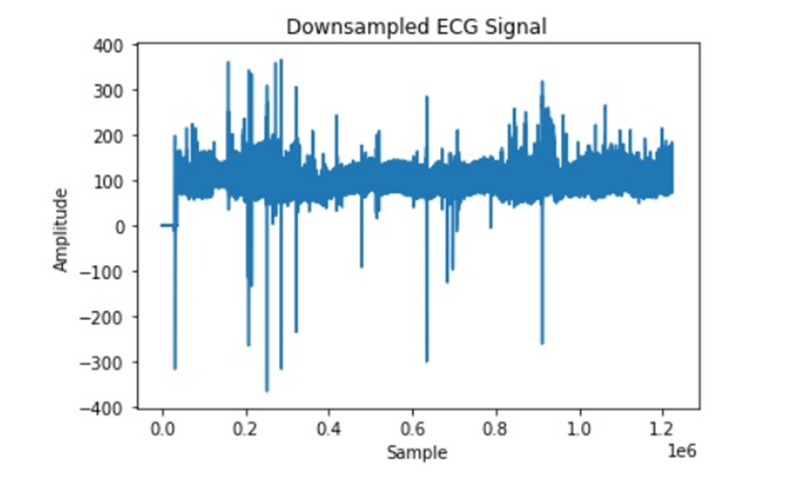

**Fig 3:** ECG Audio signals

***7) Time Analysis of PCG Signal:***

The Charis database's Extrasystole Category (Dataset B) for ECG categorization designates a particular kind of irregular heartbeat known as a premature contraction. It happens when the heart beats too quickly, frequently as a result of irregular cardiac electrical activity. Atrioventricular, ventricular, and junctional extrasystoles are the three types of extrasystoles that can be distinguished. Extrasystoles can be distinguished in the context of ECG categorization by examining the ECG signal and looking for anomalous patterns, such as early beats or irregular heart rhythms. These patterns can be recognized by machine learning algorithms, which can then be trained to classify the ECG signal as normal or pathological, including extrasystoles.

***8) Frequency Analysis of PCG Signal:***

The primary focus of the research is on the categorization of PCG and ECG signals using a fusion technique based on the improved D-S theory and a combination of BiLSTM (Bidirectional Long Short-Term Memory) and GoogLeNet networks. The PCG and ECG signals are preprocessed—that is, filtered—before being submitted to the BiLSTM network for classification, as the paper does mention. The time-frequency diagram of each signal is also obtained by applying wavelet transform to the filtered PCG and ECG signals. The resulting images are then scaled and transformed into an appropriate size for GoogLeNet network training. Next, the PCG and ECG signals' time-frequency graphs are classified using the GoogleNet network.

***9) Time – Frequency Analysis of PCG Signal:***

According to the study "Time-frequency analysis of phonocardiogram signals using wavelet transform: a comparative study" published in Computational Methods in Biomechanics and Biomedical Engineering, wavelet transform can be used to perform time-frequency analysis of PCG (phonocardiogram) signals. The study aims to identify the optimal wavelet for getting a dependable TFR (time-frequency representation) by comparing the performance of eight real varieties of the most popular wavelets on typical PCG data suggesting cardiac problems. According to the findings, the Morlet wavelet is the most trustworthy wavelet for PCG signal time-frequency analysis.

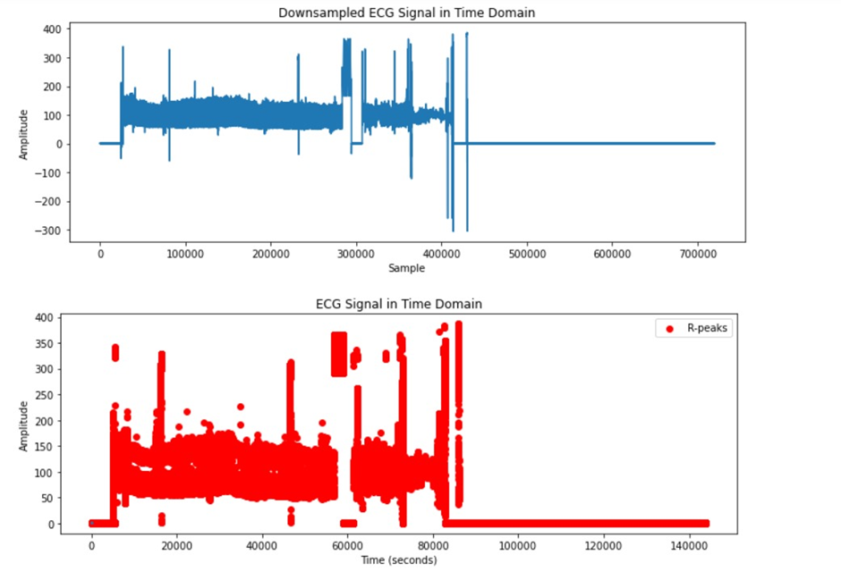

**Fig- 4**: **Time Domain Features:** Mean RR Interval:Signifies the average duration between consecutive R-peaks in the ECG signal. Standard Deviation of RR Intervals (SDNN): Evaluates the variability of RR intervals, offering information about heart rate variability. Root Mean Square of Successive RR Interval Differences (RMSSD): Indicates the level of variability between successive RR intervals.

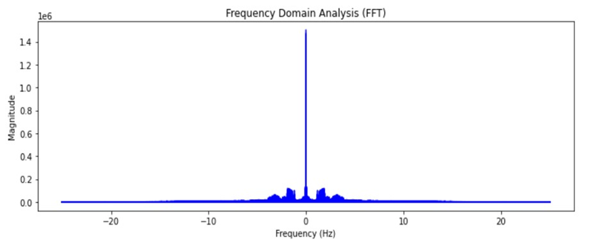

**Fig. 5:** Frequency domain features such as Power Spectral Density (PSD), Dominant Frequency

*III. RESULTS AND DISCUSSION*

***Confusion Matrix:***

The confusion matrix summarizes the predictions against the actual true records and shows the number of true positives, false positives, true negatives, and false negatives. This can help you evaluate the effectiveness of your ECG classification model and identify areas for improvement. For example, if you have a classification problem into two categories (eg, normal and abnormal ECG signals), the confusion matrix might look like this: [[90 10]

[5 85]].

This means that: 90 truly normal ECG signals were correctly classified as normal (true positives), 10 truly normal ECG signals were misclassified as abnormal (false positives), 5 truly abnormal ECG signals were misclassified as normal (false negatives), n 85 true abnormal ECG signals were correctly classified as abnormal (true negatives). By analyzing the confusion matrix, you can gain insight into the performance of your ECG classification model and make improvements for better accuracy .

***Precision and F1-Score:***

Accuracy measures the ratio of correctly predicted positive detections to predicted positive detections and highlights how many of the predicted positive cases were actually positive. This is very important in medical diagnosis, where false positive results can lead to unnecessary treatments or additional tests. In ECG classification, if the model predicts an abnormal heartbeat, the accuracy represents the proportion of truly abnormal predictions. The F1 score, on the other hand, is a harmonic mean of precision and recall. It provides a single metric that balances between precision and recall, making it particularly useful when dealing with unbalanced classes. Recall (or sensitivity) measures the ratio of correctly predicted positive observations to all true positive observations, which measures the ability of the model to detect all significant occurrences of the positive class.

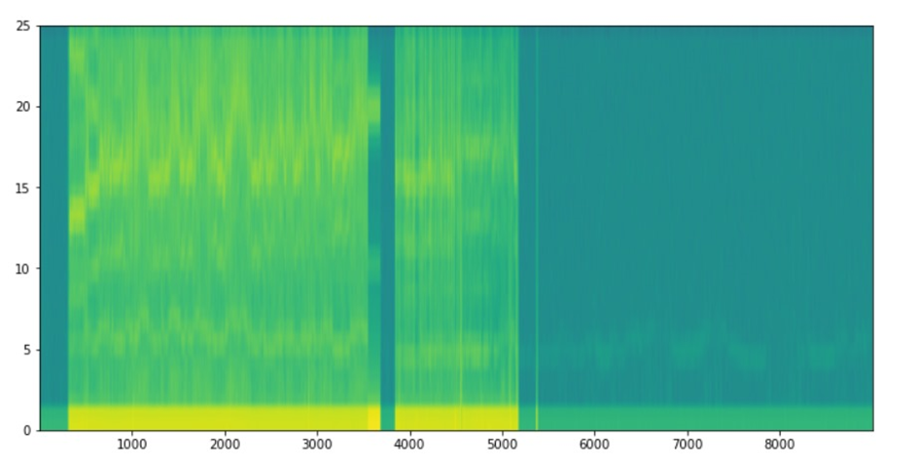

**Fig 6:** Wave transform features:Wavelet Decomposition, Statistical Measures from Wavelet Coefficients.

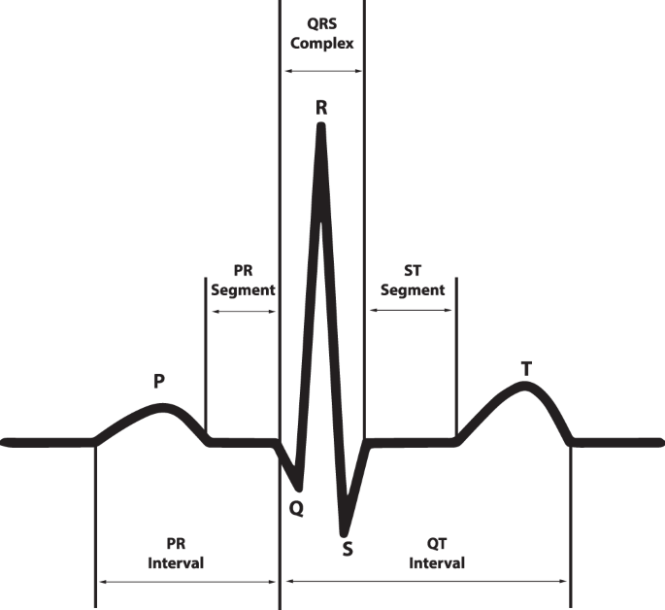**Fig-**7: The ECG waveform and segments in lead II that presents a normal cardiac cycle.

***Micro-Averaged ROC Curve:***

To construct a micro-average ROC curve, we start by obtaining the true signs and predicted probabilities of each class from the ECG classification model. Since binary classifiers traditionally use ROC curves, the multi-class problem is transformed into a multi-binary classification problem using the OvR method. In this method, each class is treated as a positive class and all other classes are considered negative.

REFERENCES

[1] Sprague, H. B., & ONGLEY, P. A. (1954). The clinical value of phonocardiography. *Circulation*, 9(1), 127-134.

[2] Gündüz, A. F., & Talu, F. (2022). PCG frame classification by classical machine learning methods using spectral features and MFCC based features. *Avrupa Bilim ve Teknoloji Dergisi*, (42), 77-82.

[3] Arora, V., Leekha, R., Singh, R., & Chana, I. (2019). Heart sound classification using machine learning and phonocardiogram. *Modern Physics Letters B*, 33(26), 1950321.

[4] Hao, J., & Ho, T. K. (2019). Machine learning made easy: a review of scikit learn package in python programming language*. Journal of Educational and Behavioral Statistics*, 44(3), 348-361.

[5] Krishnan, P. T., Balasubramanian, P., & Umapathy, S. (2020). Automated heart sound classification system from unsegmented phonocardiogram (PCG) using deep neural network. *Physical and Engineering Sciences in Medicine*, 43(2), 505-515.

[6] Singh, S. A., Majumder, S., & Mishra, M. (2019, May). Classification of short unsegmented heart sound based on deep learning. *In 2019 IEEE international instrumentation and measurement technology conference (I2MTC)*, *IEEE*, pp. 1-6.

[7] He, R., Wang, K., Zhao, N., Liu, Y., Yuan, Y., Li, Q., & Zhang, H. (2018). Automatic detection of atrial fibrillation based on continuous wavelet transform and 2D convolutional neural networks. *Frontiers in physiology,* 9, 1206.

[8] Nilanon, T., Yao, J., Hao, J., Purushotham, S., & Liu, Y. (2016, September). Normal/abnormal heart sound recordings classification using convolutional neural network. *In 2016 computing in cardiology conference (CinC)* (pp. 585-588). *IEEE*.

[9] VP, H. V., Rahiman, A., & Abraham, L. (2022). A review on the impact of deep learning in the identification of atrial septal defect and a comparative study on the algorithms employed in the imaging modalities. *Journal of Pharmaceutical Negative Results*, 1922-1930.

[10] Yaseen, Son, G. Y., & Kwon, S. (2018). Classification of heart sound signal using multiple features. *Applied Sciences*, 8(12), 2344

[11] Singh, M., & Cheema, A. (2013). Heart sounds classification using feature extraction of phonocardiography signal. *International Journal of Computer Applications*, 77(4).

[12] Wang, X., Zheng, Y., Zhao, Z., & Wang, J. (2015). Bearing fault diagnosis based on statistical locally linear embedding. *Sensors*, 15(7), 16225-16247. [13] Rajagopalan, R., & Subramanian, B. (2003, July). Removal of impulse noise from audio and speech signals. In Signals, Circuits and Systems, 2003. SCS 2003. *International Symposium on* (Vol. 1, pp. 161-163). *IEEE*. [14] Prasadh, S. K., Natrajan, S. S., & Kalaivani, S. (2017, November). Efficiency analysis of noise reduction algorithms: Analysis of the best algorithm of noise reduction from a set of algorithms. *In 2017 International Conference on Inventive Computing and Informatics (ICICI)* (pp. 1137- 1140). *IEEE*.

[15] Jamil, S., & Roy, A. M. (2023). An efficient and robust phonocardiography (pcg)-based valvular heart diseases (vhd) detection framework using vision transformer (vit). *Computers in Biology and Medicine*, 158, 106734.

[16] Barnova, K., Kahankova, R., Jaros, R., Litschmannova, M., & Martinek, R. (2022). A comparative study of single-channel signal processing methods in fetal phonocardiography. *Plos one*, 17(8), e0269884.

[17] Abo-Zahhad, M., Ahmed, S. M., & Abbas, S. N. (2014). Biometric authentication based on PCG and ECG signals: present status and future directions. *Signal, Image and Video Processing*, 8, 739-751.

[18] Canning, C., Guo, J., Narang, A., Thomas, J. D., & Ahmad, F. S. (2023). The Emerging Role of Artificial Intelligence in Valvular Heart Disease. *Heart Failure Clinics*, 19(3), 391-405.

[19] Bourouhou, A., Jilbab, A., Nacir, C., & Hammouch, A. (2019). Heart sounds classification for a medical diagnostic assistance. 88-103.

[20] Omarov, B., Saparkhojayev, N., Shekerbekova, S., Akhmetova, O., Sakypbekova, M., Kamalova, G., ... & Akanova, Z. (2022). Artificial Intelligence in Medicine: Real Time Electronic Stethoscope for Heart Diseases Detection. Computers, *Materials & Continua*, 70(2).

[21] Gomes, E. F., Bentley, P. J., Pereira, E., Coimbra, M. T., & Deng, Y. (2013). Classifying Heart Sounds-Approaches to the PASCAL Challenge. *Healthinf*, 2013, 337-340.